**Problem Description 1:**

Write a program that prompts the user to insert an integer value, a decimal number, and his/her name and print the inserted

SOLUTION

1. #include <stdio.h>
3. int main()
4. {
5. int num1;
6. float num2;
7. char name[20];
9. printf("Enter a Number: ");
10. scanf("%d", &num1);
12. printf("Enter a decimal number: ");
13. scanf("%f", &num2);
15. printf("Enter your name: ");
16. scanf("%s", name);
18. printf("The Number is : %d\n", num1);
19. printf("The Decimal Number is : %f\n", num2);
20. printf("Your name is : %s \n", name);
21. return 0;
22. }

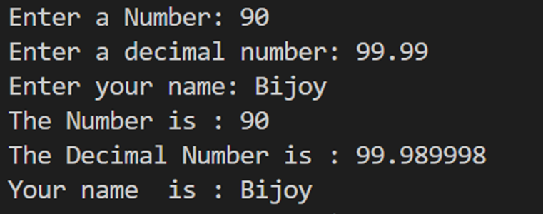

**Problem Description 2:**

Write a program that reads in the radius of a

circle and prints the circle’s diameter, circumference, and area

.

SOLUTION

1. #include <stdio.h>
3. int main()
4. {
5. float radius, circumference, area, diameter;
7. printf("Enter the radius of the circle: ");
8. scanf("%f", &radius);
10. diameter = 2 * radius;
11. circumference = 2 * 3.14159 * radius;
12. area = 3.14159 * radius * radius;
14. printf("The circle's diameter is: %f\n", diameter);
15. printf("The circle's circumference is: %f\n", circumference);
16. printf("The circle's area is: %f\n", area);
18. return 0;
19. }

**Problem Description:3**

Write a program that reads in 8 numbers and prints their mean, median and standard deviation.

SOLUTION

1. #include<stdio.h>
2. #include<math.h>
3. int main()
4. {
5. int i,j,n,temp;
6. float mean,standard_deviation,median,sum=0.0;
7. int a[20];
8. printf("Enter the value of n:\n");
9. scanf("%d",&n);
10. printf("Enter %d elements:\n",n);
11. for(i=0;i<n;i++)
12. {
13. scanf("%d",&a[i]);
14. }
15. for(i=0;i<n;i++)
16. {
17. sum+=a[i];
18. }
19. mean=sum/n;
20. sum=0.0;
21. for(i=0;i<n;i++)
22. {
23. sum=sum+pow((a[i]-mean),2);
24. }
25. standard_deviation=sqrt(sum/n);
26. for(i=0;i<n;i++)
27. {
28. for(j=i+1;j<n;j++)
29. {
30. if(a[i]>a[j])
31. {
32. temp=a[i];
33. a[i]=a[j];
34. a[j]=temp;
35. }
36. }
37. }
38. if(n%2==0)
39. {
40. median=(a[(n-1)/2]+a[n/2])/2.0;
41. }
42. else
43. {
44. median=a[n/2];
45. }
46. printf("Mean = %.2f\n", mean);
47. printf("Median = %.2f\n", median);
48. printf("Standard Deviation = %.2f", standard_deviation);
49. return 0;
50. }

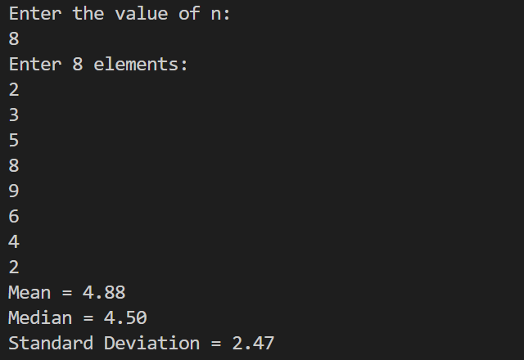

**Problem Description: 4**

Convert Celsius to Fahrenheit unit. Take the value of C as input from the user and calculate the value of F.

Procedure: Try to write the C code by using basic arithmetic operations. Try to understand the problem by seeing the sample input/output

given below.

Sample Input:

Insert numbers: Enter the Celsius value: 32

Sample Output:

The Fahrenheit value is: 89.6

SOLUTION

1. #include <stdio.h>
3. int main(void)
4. {
5. float C, F;
6. printf("Enter the Celsius value: ");
7. scanf("%f", &C);
9. F = (C * 9 / 5) + 32;
11. printf("The Fahrenheit value is: %.1f", F);
13. return 0;
14. }



**Problem Description: 5**

Write a program that will prompt the user for two integers a and b. Then swap (interchange) the values of a and b. That means, a should get the value of b and b should get the value of a.

Sample Input:

Enter a: 7

Enter b: 3

SOLUTION

1. #include<stdio.h>
2. int main() {
3. int a,b,c;
4. printf("Enter the value of A:");
5. scanf("%d", &a);
6. printf("Enter the value of B:");
7. scanf("%d", &b);
8. c = a;
9. a = b;
10. b = c;
11. printf("The value of A: %d\n",a);
12. printf("The value of B: %d\n",b);
13. }

